

***INSTITUTE OF INFORMATION TECHNOLOGY***

***JAHANGIRNAGAR UNIVERSITY***

**Number of Assignment :** 01

**Submission Date :** 08/11/2022

**Course Tittle :** Microprocessor and Interfacing

**Course Code :** ICT - 3203

**Submitted To Submitted By**

Dr. Rashed Mazumder Md. Shakil Hossain

Assistant Professor Roll – 2023

IIT – JU 3nd year 2nd Semester

IIT – JU

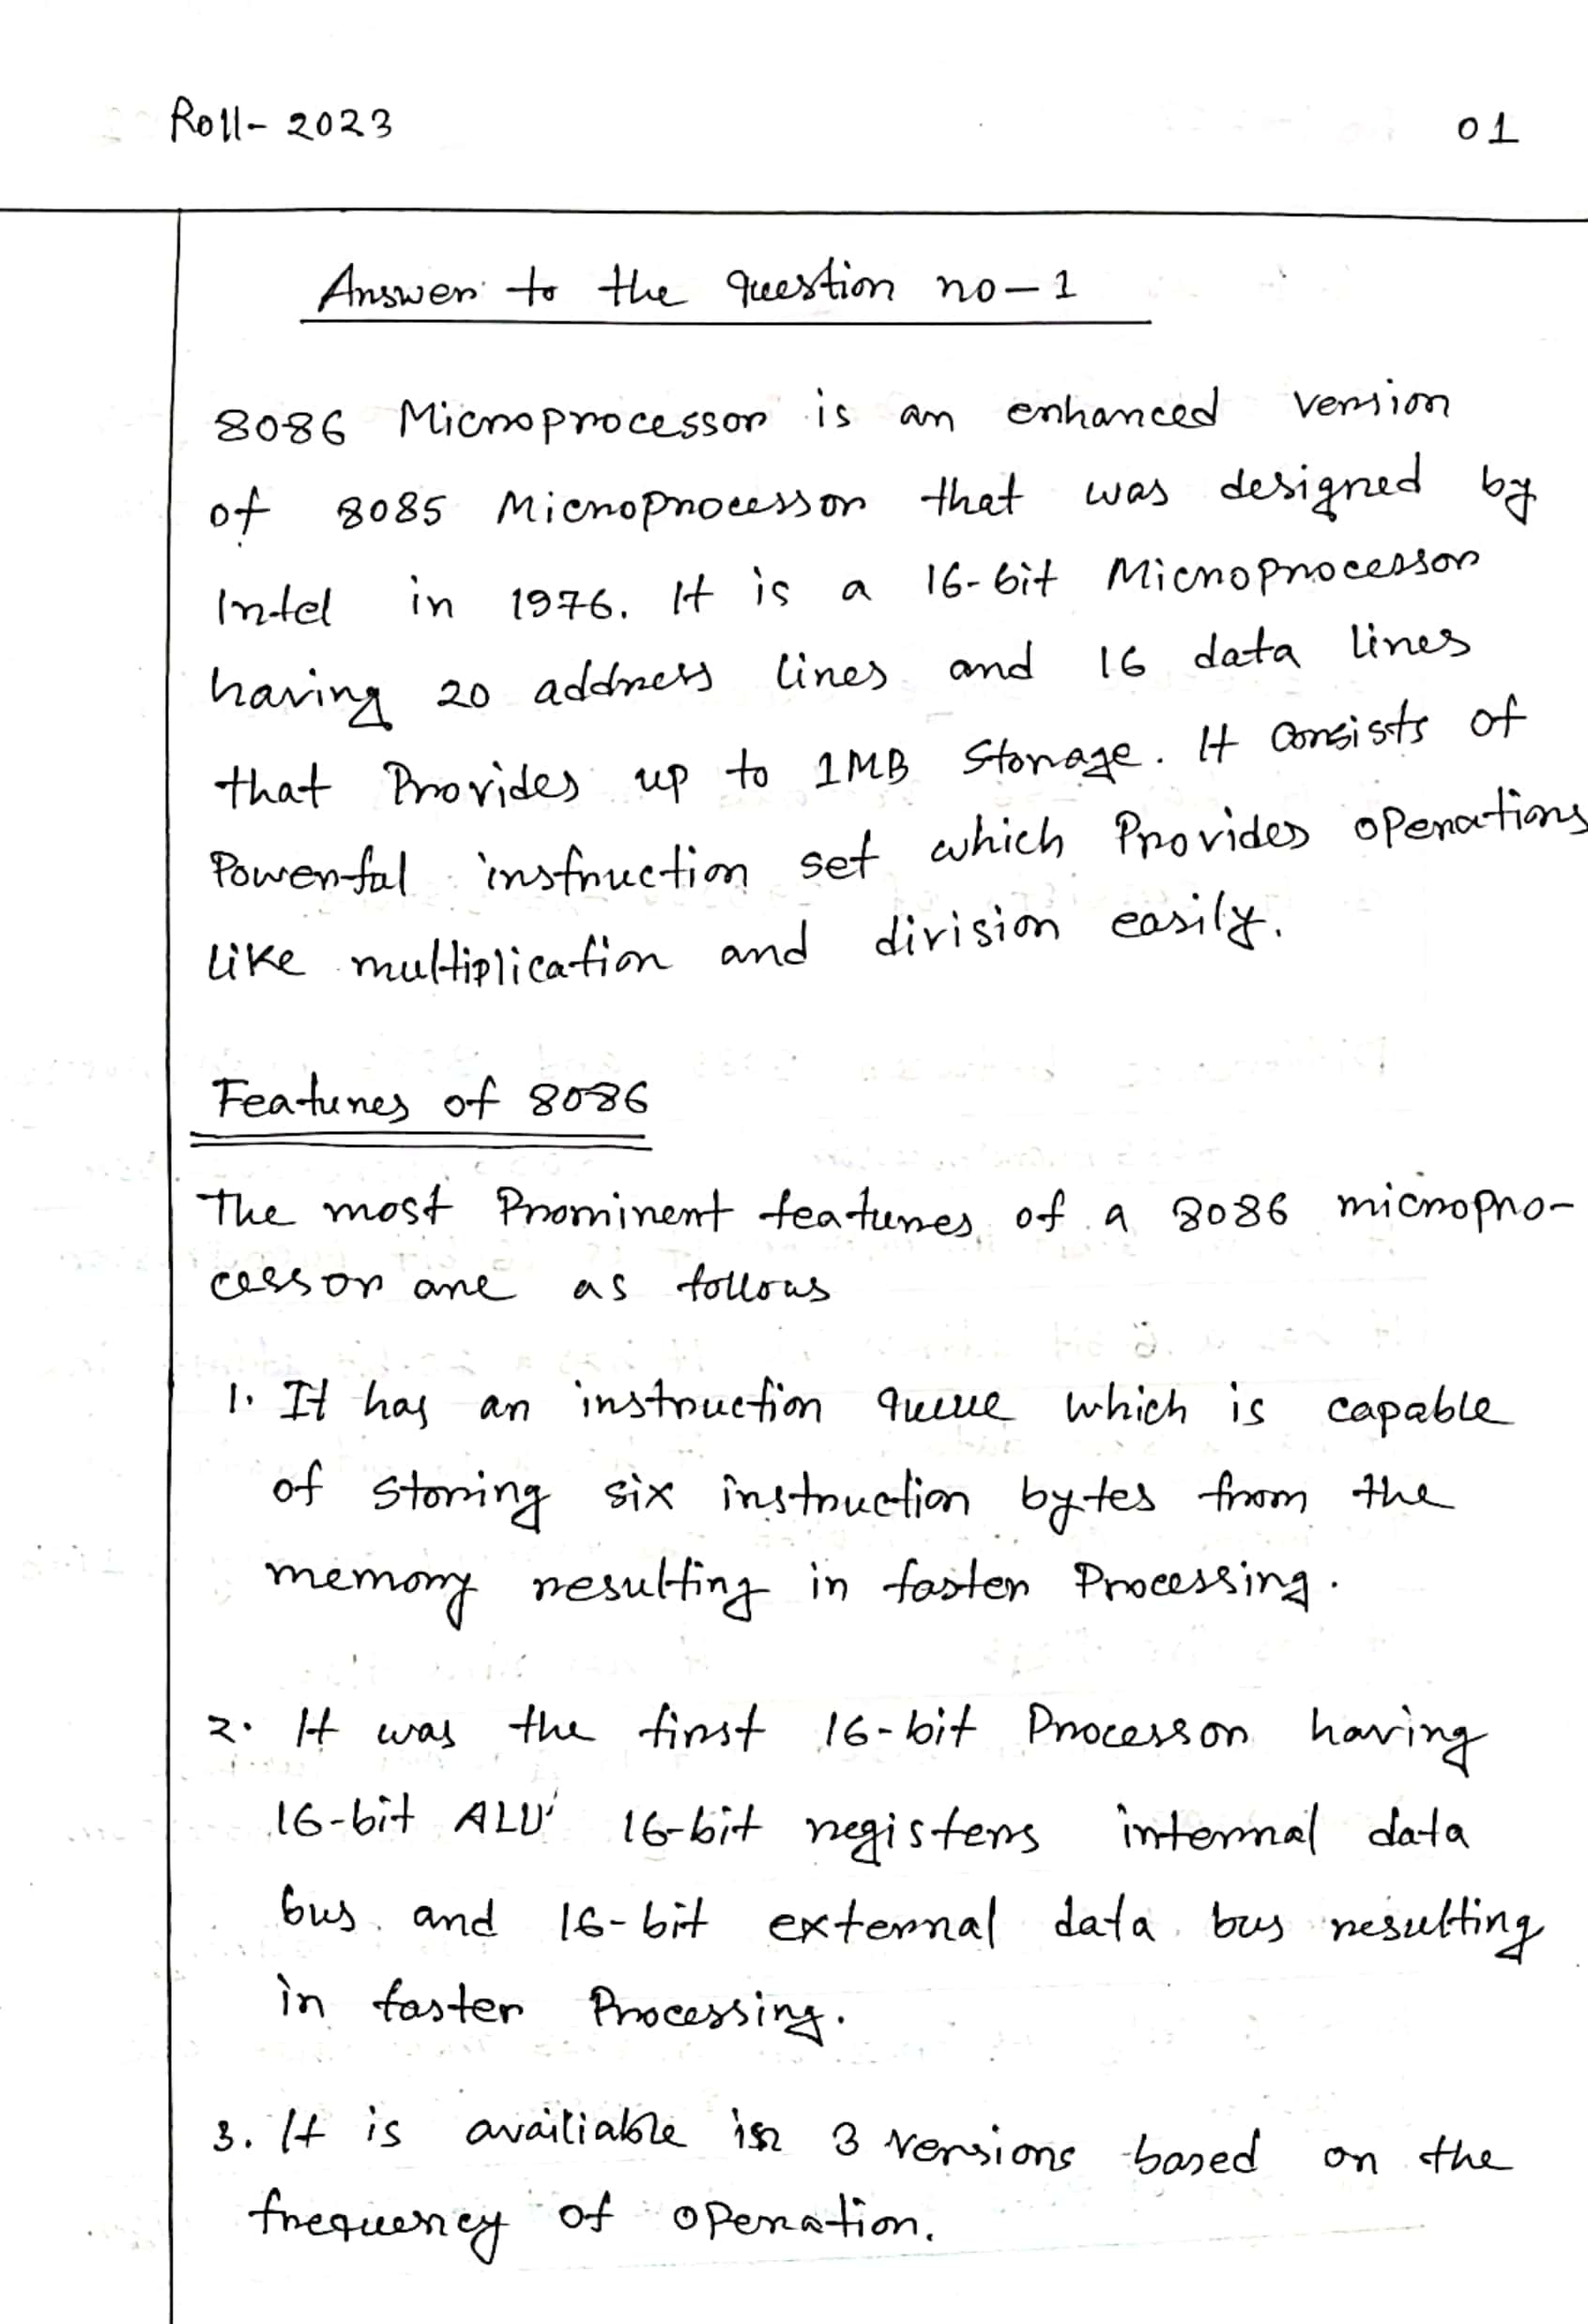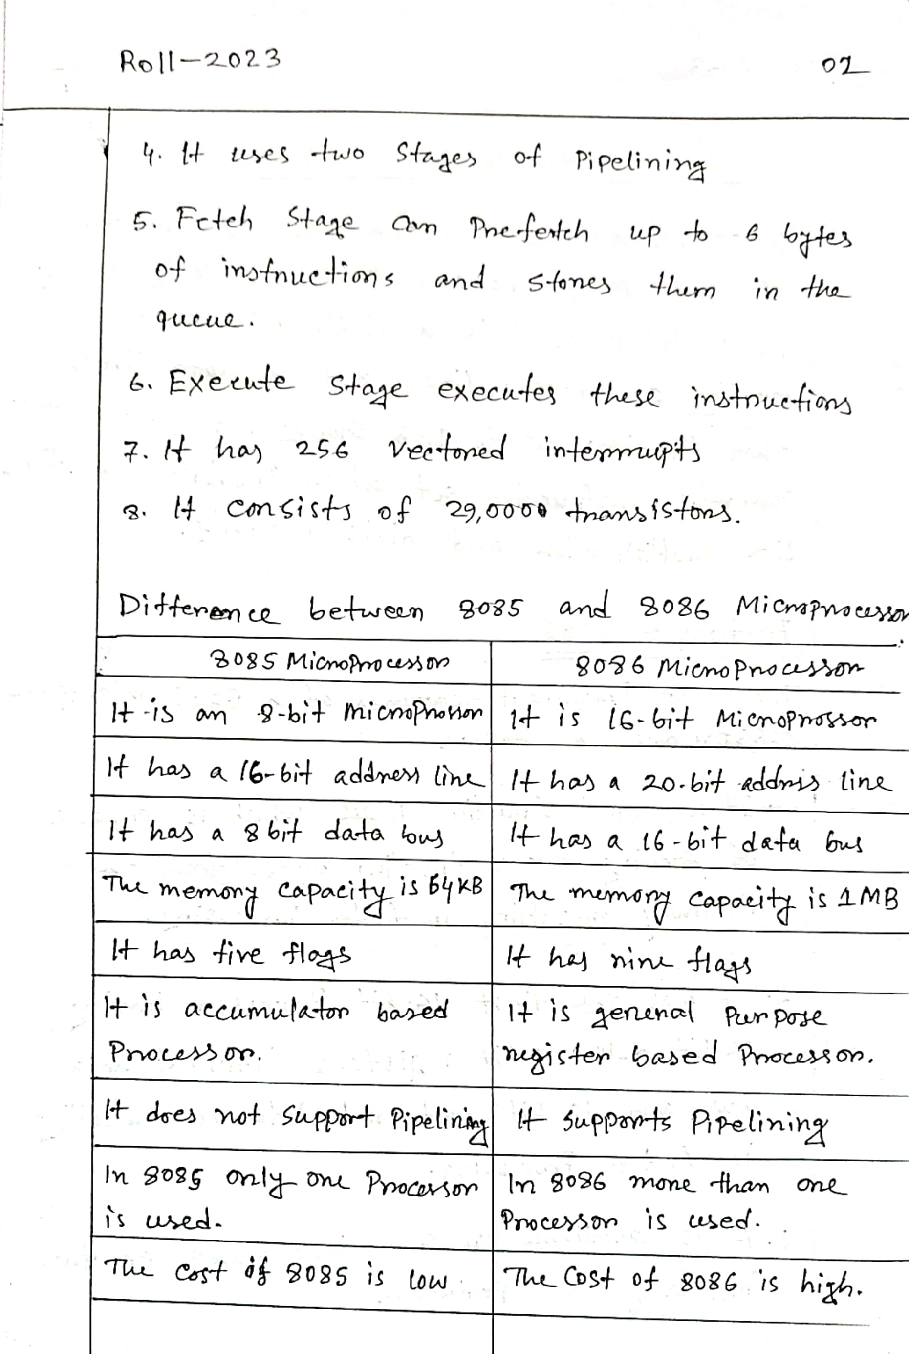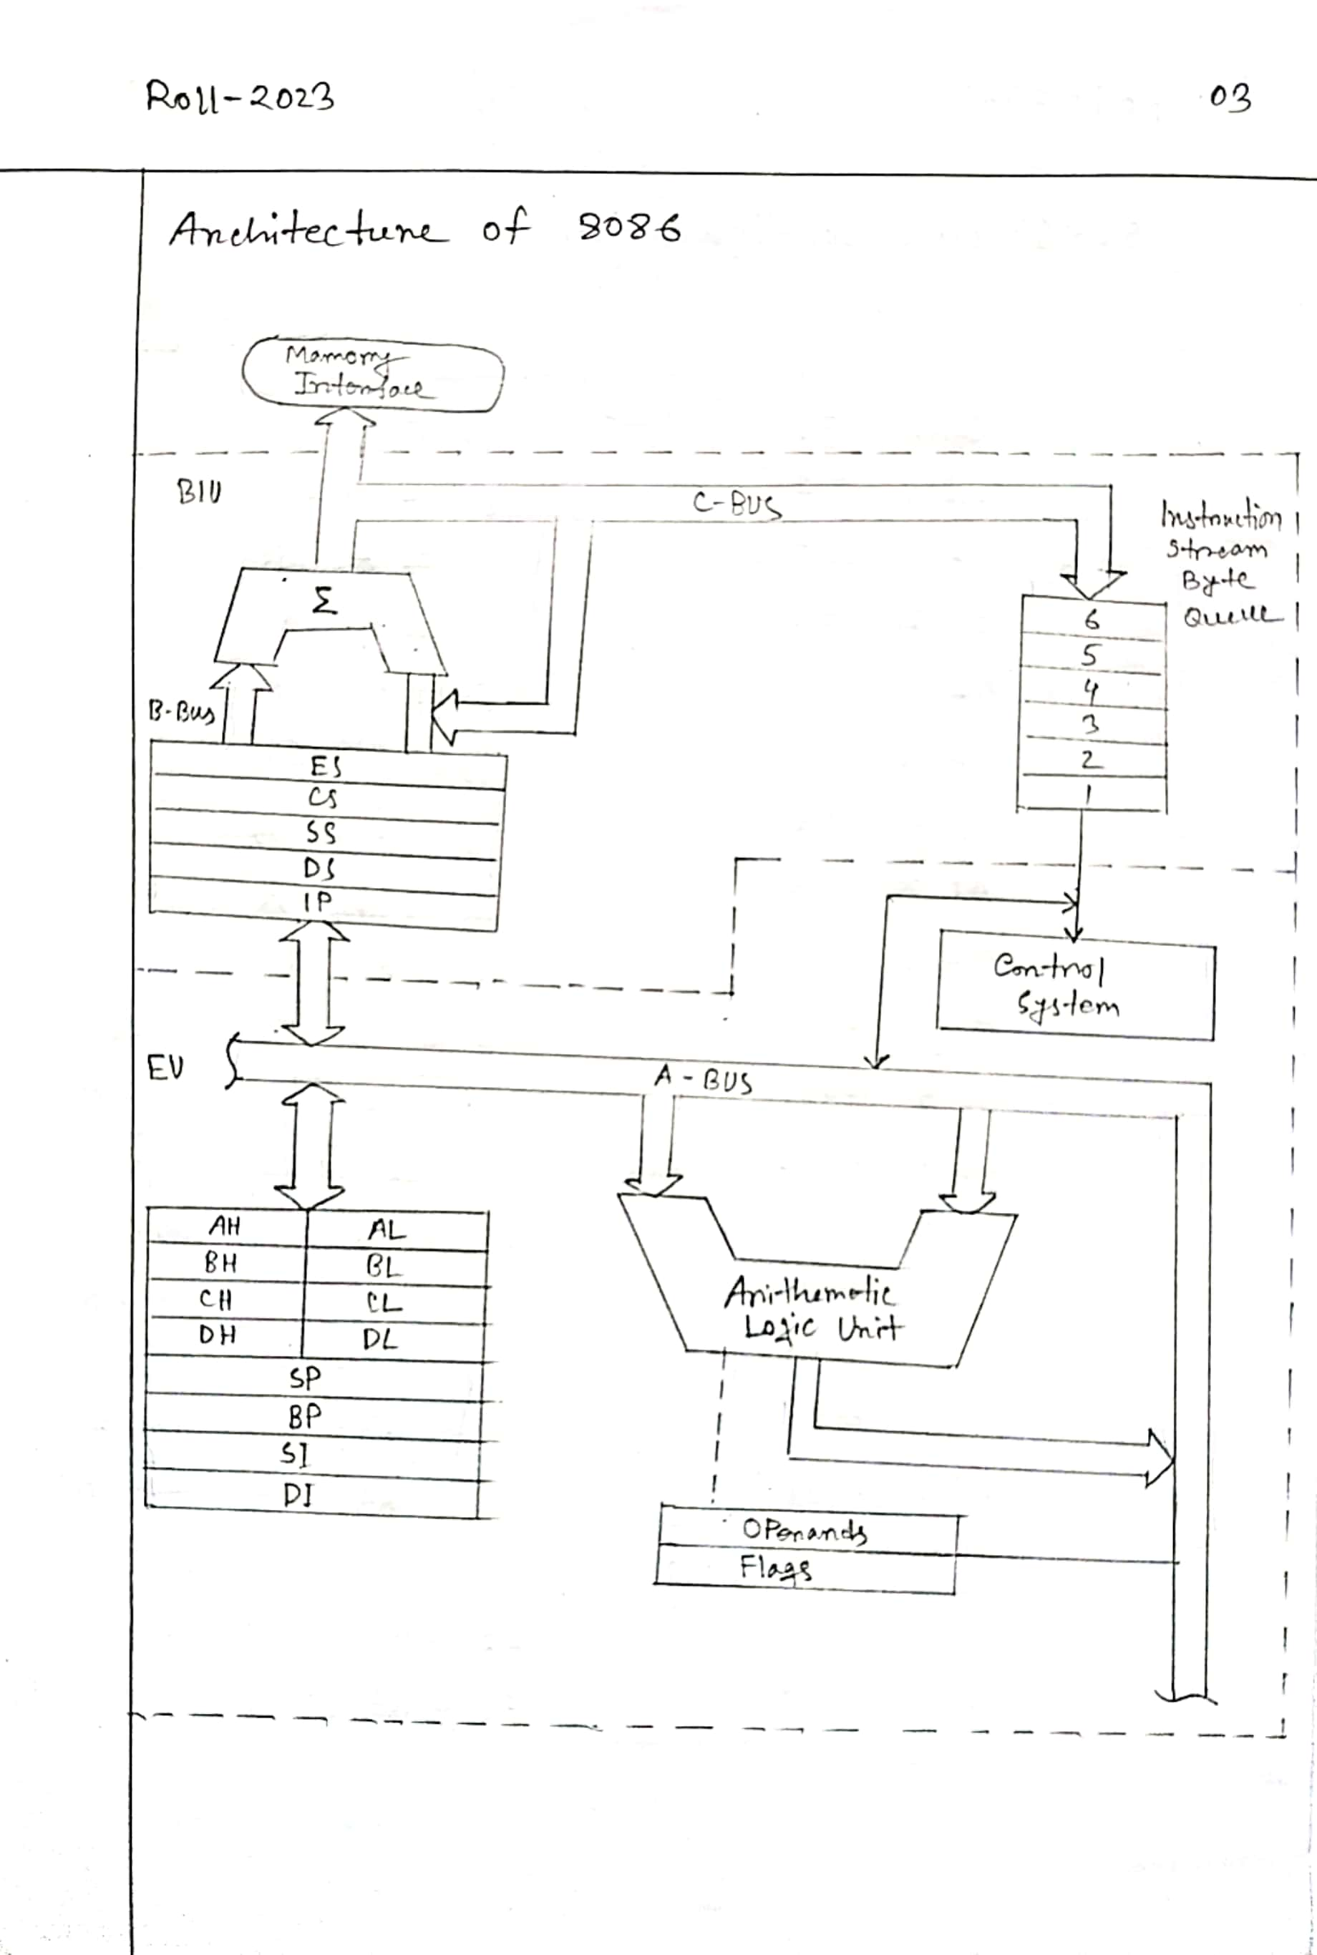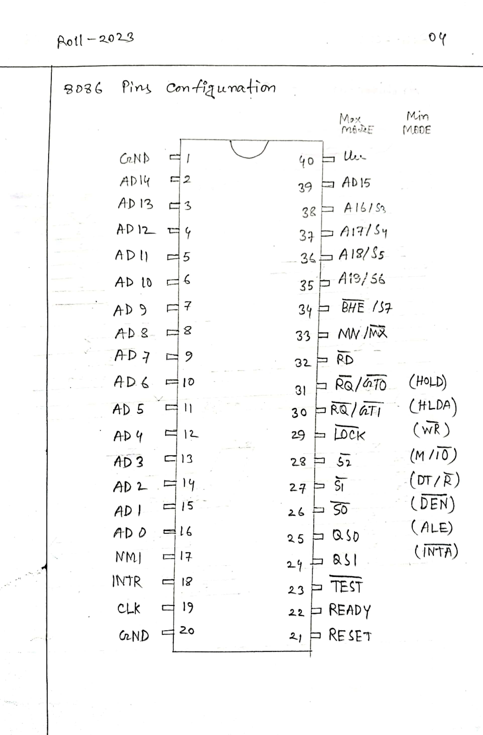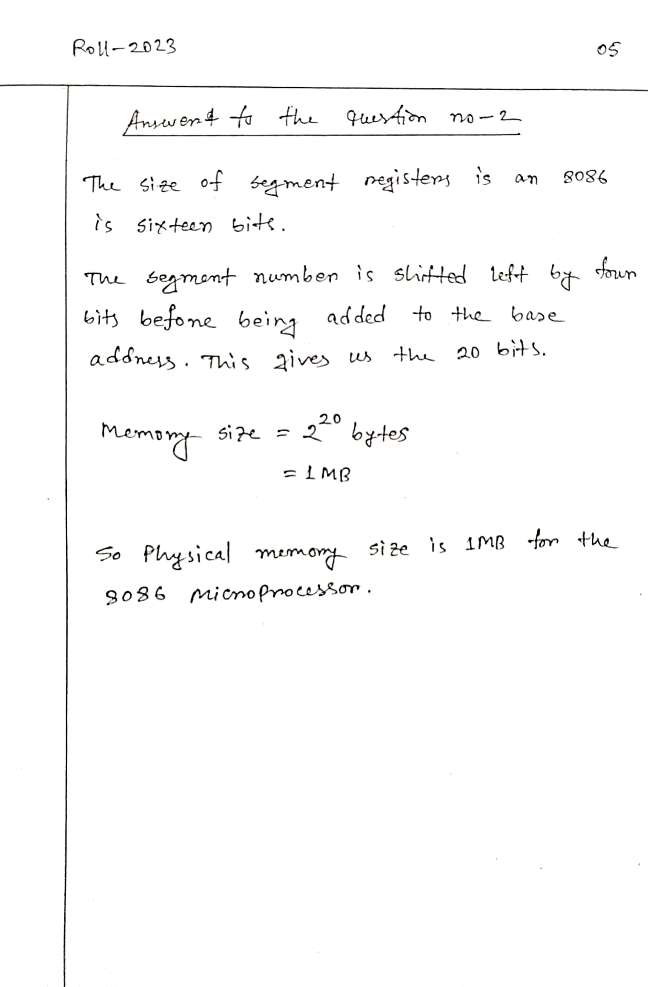

**THE END**